# 

# Detailed Notes: Elasticsearch Console Tool

## Overview

* - **Purpose**: Explore the Console tool, a **development utility** (as this tool is used during development phase) for interacting with Elasticsearch.
* - **Audience**: If already familiar, you can skip this lecture as it may not introduce new information.

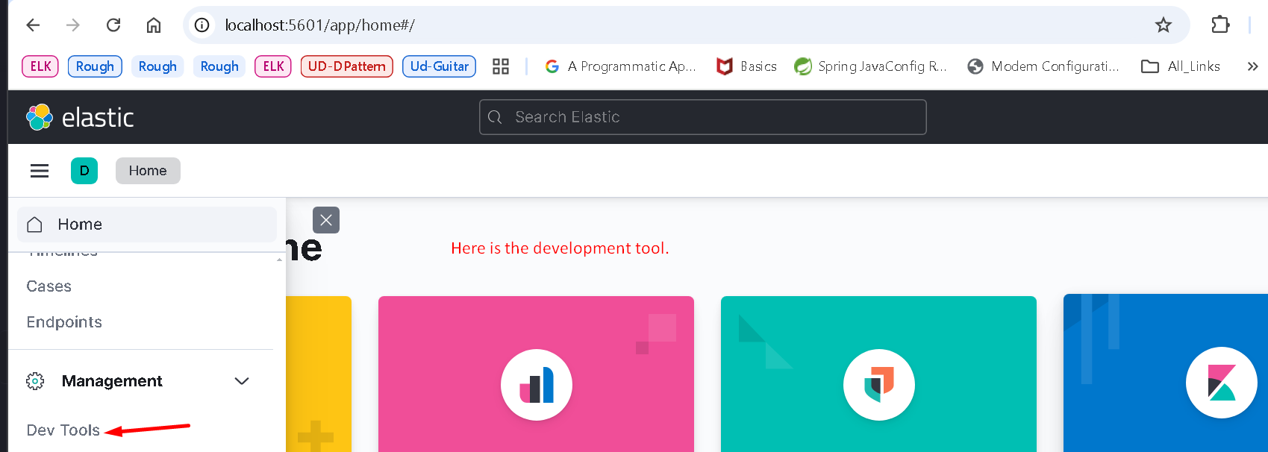

## Key Features of Console Tool

* - **Simplified Querying**: Allows sending queries to Elasticsearch with easier syntax compared to cURL.
* - **Helpful Features**:

- JSON formatting.

- Auto-completion.

- Query history and local storage of queries.

## Accessing the Console Tool

* - **Location**: Found within the “Dev Tools” app in Kibana.
* - **Interface**:

- **Left Pane**: Editor for writing queries.

- **Right Pane**: Displays query results.

## Writing and Running Queries

1. 1. **Basic Query**:

- Example: Query cluster health.

- **Steps**:

1. Enter the HTTP verb (e.g., `GET`).

2. Add the request path (e.g., for Cluster health API).

3. Use auto-completion for assistance.

4. Optionally include a leading forward slash (`/`) in the path.

5. Run the query using the triangle button to the right.

- **Results**: Displayed as formatted JSON.

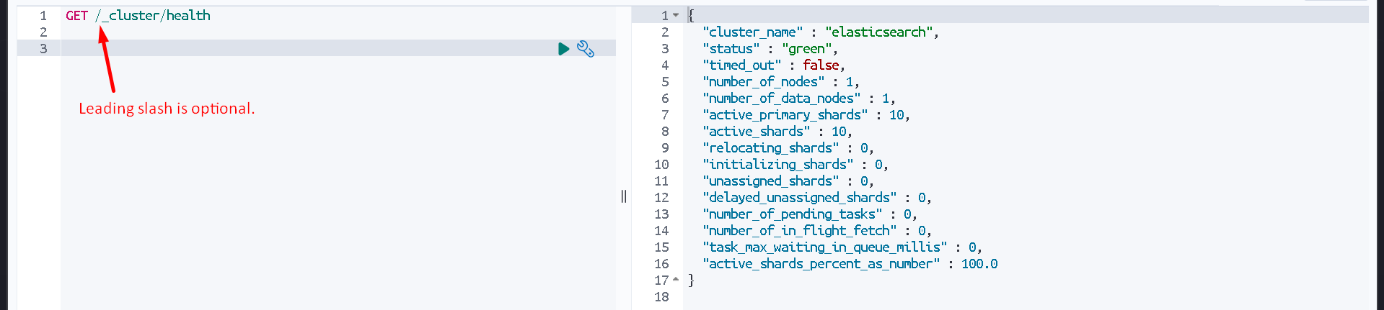

1. 2. **Query with Request Body**:

- Example: `match_all` query.

- **Structure**:

- HTTP verb and request path.

- Request body containing parameters.

- **Execution**: Same process as above; results appear in the right pane.

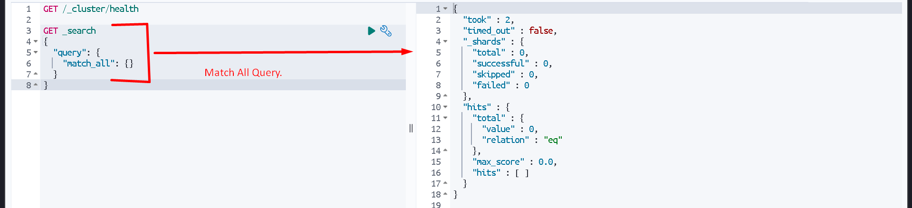

## Convenience Features

* - **Query Storage**:

- Queries are saved to local storage automatically. So, we can leave console tool (Dev Tool)

- Query history is maintained for quick access to previous queries.

* - **Custom Variables**:

- Variables can be defined and reused in queries.

- Useful for repetitive elements like index names.  
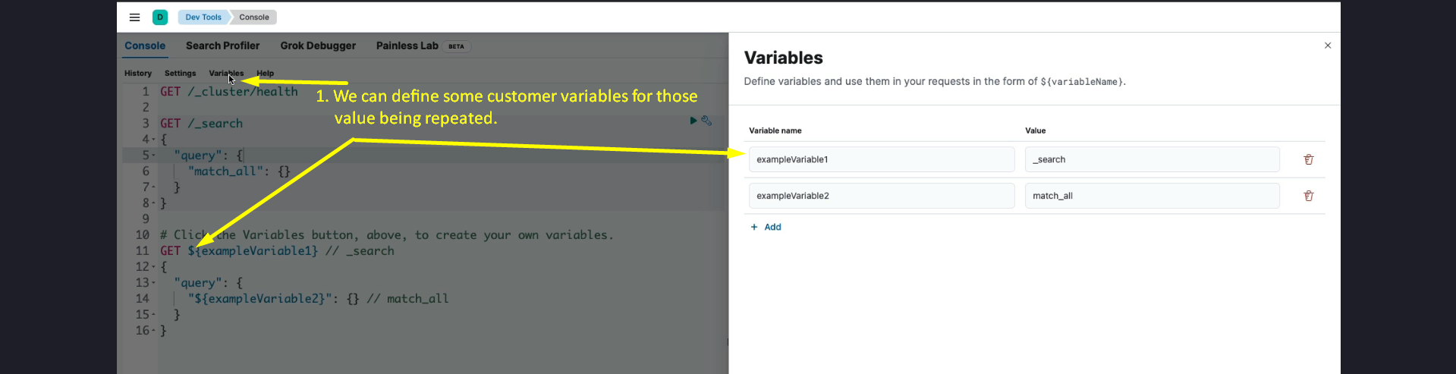

That is all about Console Tool used to quickly run queries against Elasticsearch Cluster.

## Use Cases

1. 1. **Development**:

- Writing and testing new queries.

- Easily porting queries to production.

1. 2. **Debugging**:

- Analyzing production queries.

- Inspecting Elasticsearch cluster issues.

## Comparison to cURL

* - Easier and faster than typing cURL commands.
* - Handles authentication and other complexities automatically.

## Limitations

* - Primarily a development tool.
* - Minimal use in this course, but knowledge of its operation is beneficial for upcoming tasks (e.g., adding index templates in the next lecture).

## Summary

* - **Purpose**: A user-friendly tool for interacting with Elasticsearch.
* - **Advantages**:

- Simplifies query creation.

- Offers time-saving features like auto-completion and query history.

- Useful for both development and debugging.

* - **Next Steps**: Practice with the tool by adding index templates in the following lecture.